**Research**

**DOMINOES:**

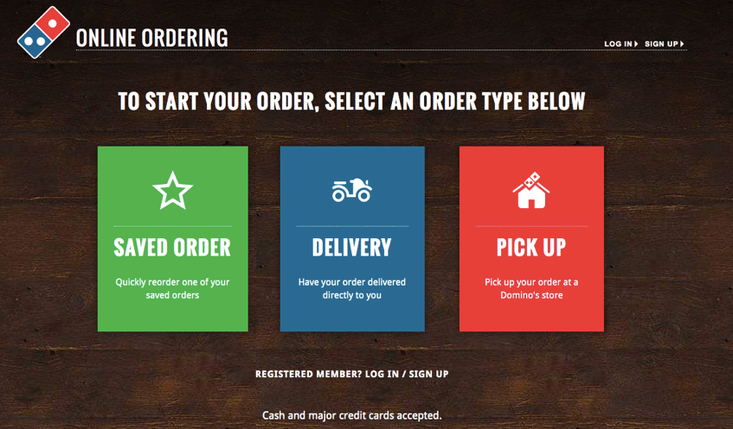

Dominoes starts off the ordering process by asking the user whether they want their pizza delivered, or if they want to pick it up.

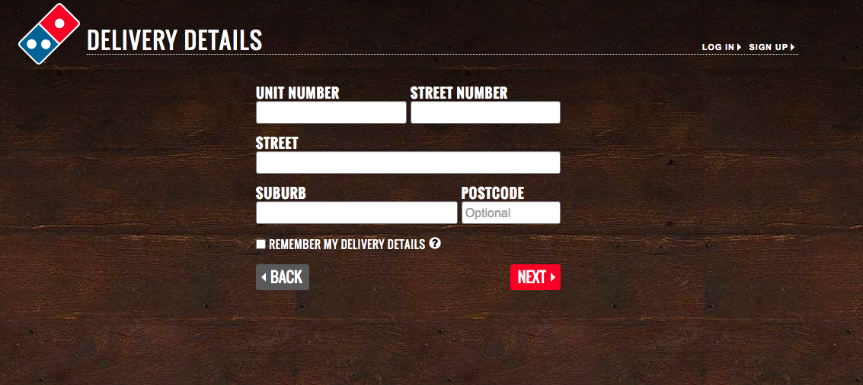

For delivery, they immediately ask the user their address. I didn’t go any further with the delivery option because I didn’t actually want to order pizza by accident.

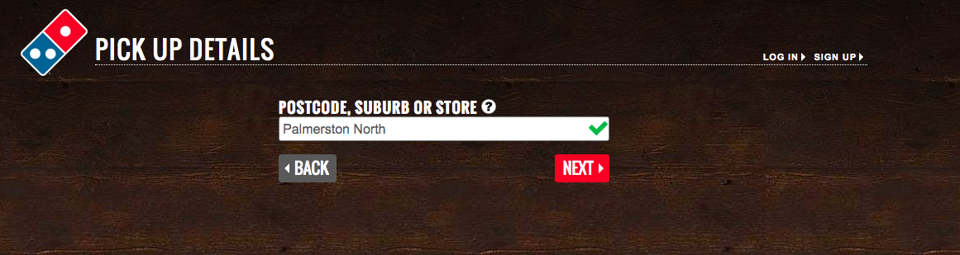

For pick-up, they ask you to enter your suburb, and then you pick your store. This won’t be necessary for my program, since it is a local pizzeria and not a large chain with multiple stores.

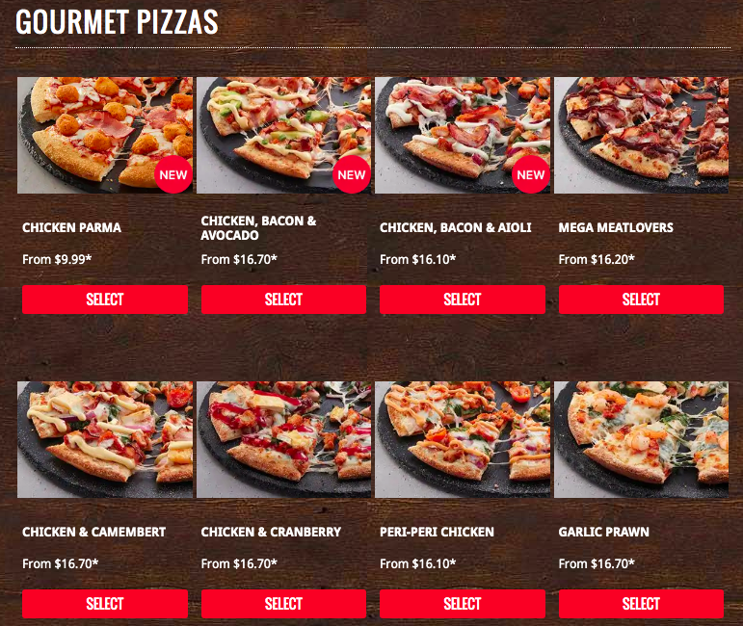

Then, they have a menu with all of their pizzas. They don’t display the descriptions right away, however they do have pictures – which I can’t do with a text-based python program.

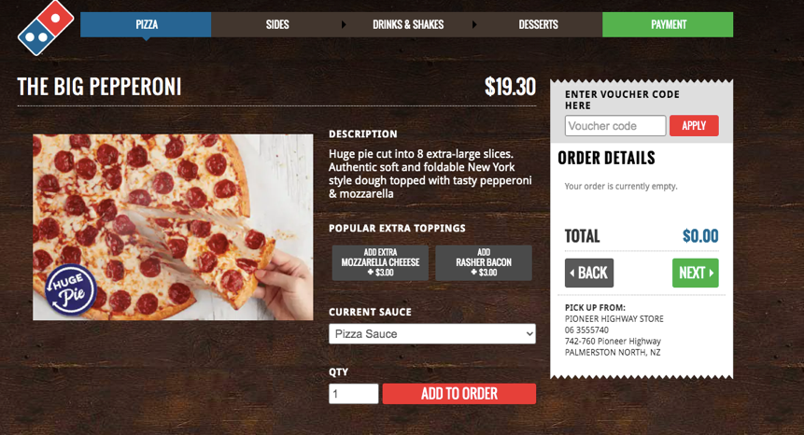

When you click “SELECT” on one of the pizzas, it takes you to this screen where you can read the pizza’s description, add extra toppings, choose your quantity, and order the pizza.

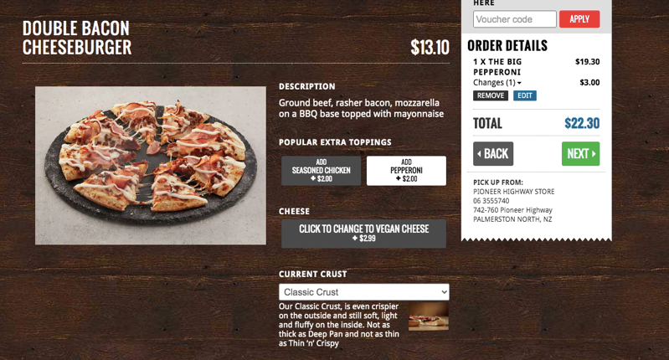

This shows what happens when I click the “add pepperoni” button. They also have a drop-down to change the crust because they have multiple crust options. However, this won’t be necessary because there is only one other crust option in my program.

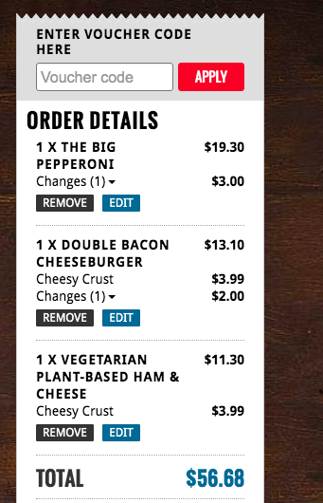

This is a screenshot of what shows up on the side of the screen, so the user can keep track of what they’re ordering. Would it be a good idea to give the option to the user to see their order throughout the ordering process?

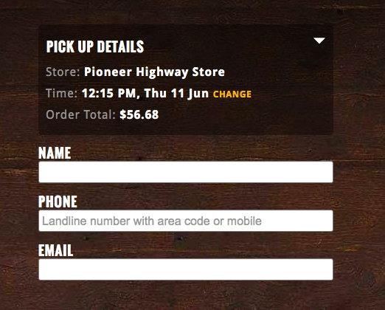

At the very end, they collect the information for the pickup – name, phone, and email. The other information (time, store, etc.) were sorted out before the order. I didn’t go any further than this because I wasn’t actually going to order the pizza.

**PIZZA HUT:**

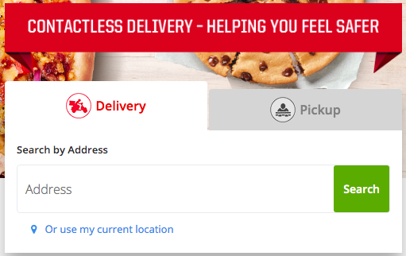

Pizza hut also started out with a choice of either delivery or pickup. It received the address input all in one field, rather than Dominoes’ multi-field input. However, instead of inputting the address it searches for a valid address on the map.

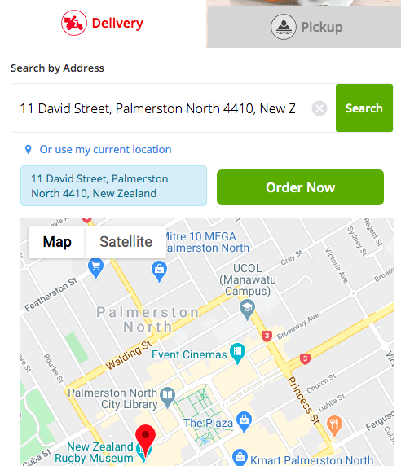

I chose a random spot on the map as an example. This would prevent errors in the entry of the address, however I do not have the time or knowledge to put in a map system.

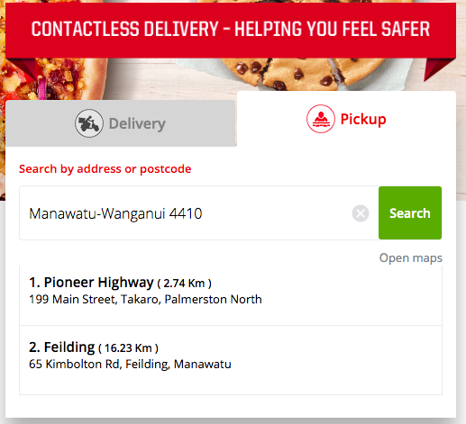

For pick-up, similarly to Dominoes, they get you to choose the store and the delivery time first thing. Still, store selection will not be an issue for me because there is only one of the pizzeria.

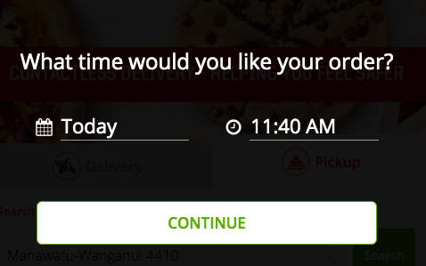

Time would matter, however I talked to the stakeholder and this is just going to be ignored in this program.

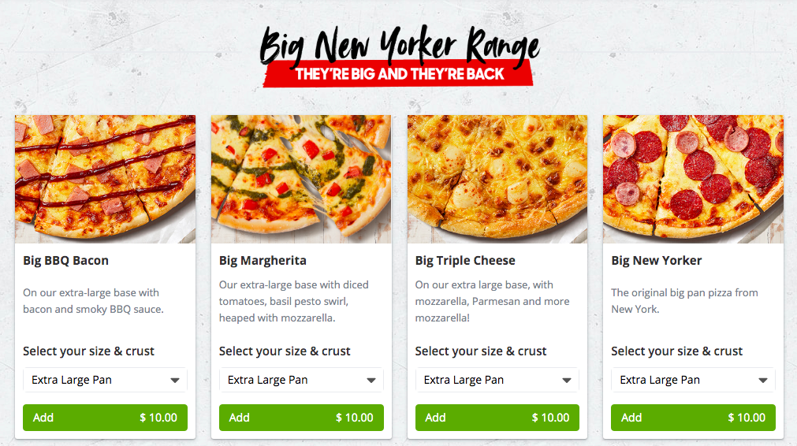

Pizza hut includes the description of the pizza in the menu, as well as the option to change the size/crust. The price on the order button will change depending on the size/crust that you choose.

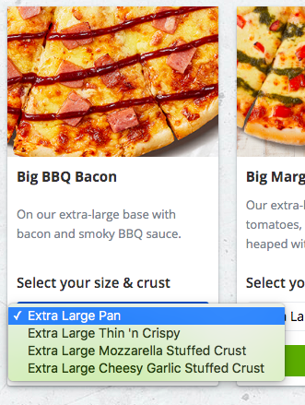 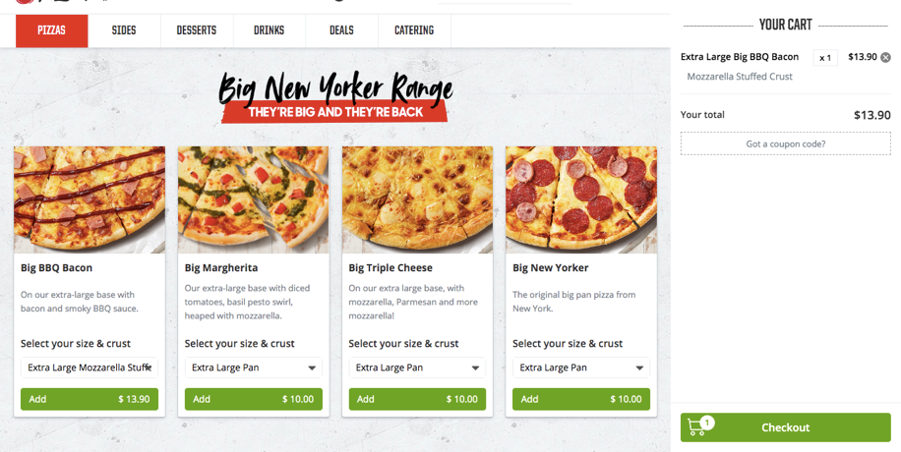

Pizza hut also has the cart up on the side of the screen so that the user knows what they are ordering throughout the process.

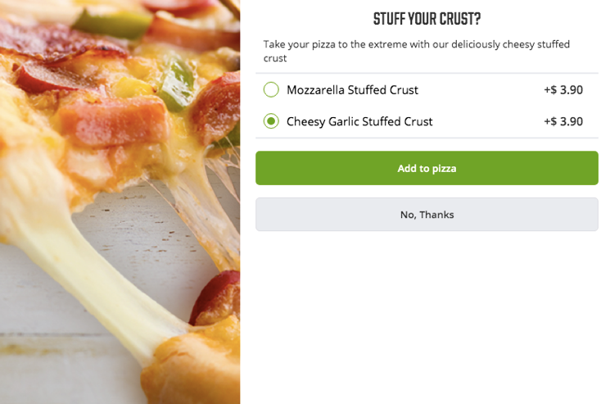 Upon ordering a pizza with a normal crust, a prompt came up offering different styles of stuffed crust.

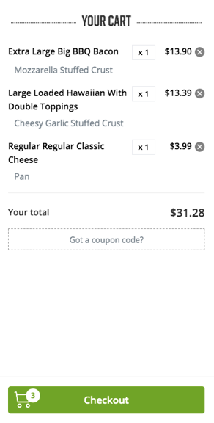 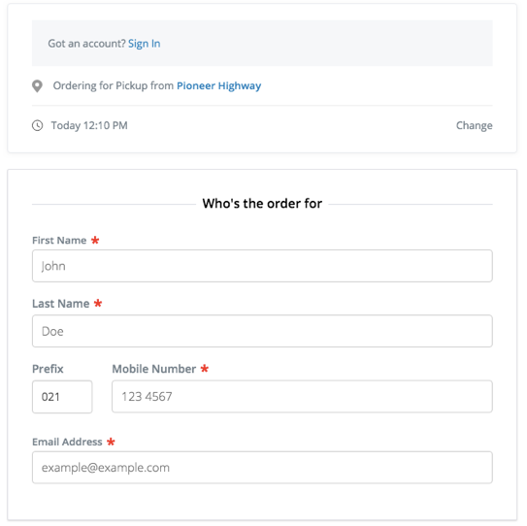

Then when you hit checkout it gathers the relevant information (same as Dominoes – name, phone number, email address).

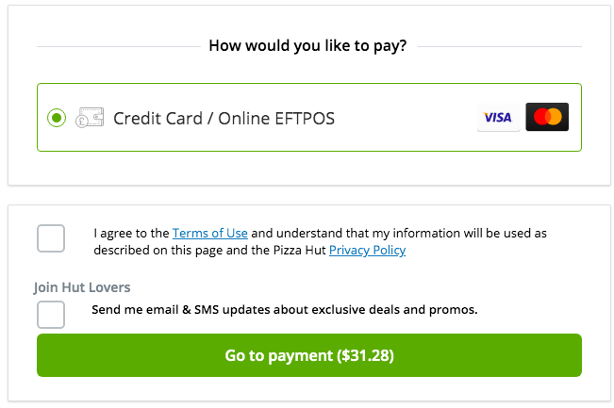

And finally, the payment option. However, since my program doesn’t have the capacity to handle payments, we can just assume that the user will pay at the store for pickup or when the delivery person arrives.